**EMPLOYEE MANAGEMENT**

**TABLE OF CONTENTS**

|  |  |
| --- | --- |
| Use- case | 1 |
| Project Summary | 1 |
| Implementation Approach | 1 |
| ENHANCEMENTS | 1 |

**1.INTRODUCTION**

**User Story 1:**

**1.1 Use-case**

This is a requirements specification for **submitting my Interview Scheduler.**

**1.2 Project Summary**

Project Name: Employee Management App

Use-Case number: 1.3.2

Project Member: N Karim

**2. IMPLEMENTATION**

2.1 Configurations (if any)

2.2 Custom Objects (If any)

**Resignation Object**

|  |  |  |
| --- | --- | --- |
| **FIELD NAME** | **TYPE** | **DESCRIPTION** |
| Resignation Number | Auto Number | Shows Resignation id. |
| Employee ID | Lookup (Employee) | Shows employee id. |
| Mode of Relieving | Picklist | Shows mode of resignation. |
| Employee Work Email | Formula (Text) | Shows employee work email id. |
| Resignation Category | Picklist | Shows resignation type. |
| Reason for Resignation | Picklist | Shows reason for resignation. |
| Reason for Termination | Picklist | Shows reason for termination. |
| Current Salary | Formula (Text) | Shows employee current salary. |
| Stage | Picklist | Shows resignation stages. |
| Status | Picklist | Shows resignation status. |
| Approval Status | Picklist | Shows approval status. |
| Resigned on | Date | Shows employee resigned date. |
| Last Working Day | Date | Shows employee last working Date. |
| Approved Date | Date | Shows employer approval date. |
| Hike Percentage | Formula (Percent) | Shows hike percentage. |
| Expected Salary | Currency | Shows the employee’s expected salary. |
| Current Position | Formula (Text) | Shows employee current position in our organization. |
| Current Level | Formula (Text) | Shows current level in our organization. |
| Type | Formula (Text) | Shows employment type of an employee. |
| Initiated Exit Process | Checkbox | Checks when the exit process is initiated. |
| Contact Number | Formula (Text) | Shows employee contact number. |
| Personal Email | Formula (Text) | Shows employee personal email. |
| Feedback on Company | Long text area | Shows feedback details given by employee. |

2.3 Customisations (If any)

2.4 Implementation approach

* Creation of **Resignation Object** with required fields along with **Look up** relationship.
* Provide picklist values for Resignation object.
* Need to update page layouts for the following objects along with necessary sections.
* Send a custom notification mail to the required role such as HR, Reporting Manager.
* Provide the access to specified object for necessary user roles.

**3. ENHANCEMENTS**

* Create convert button for initiation of exit process automatically.
* Created flows to automate stage, withdrawal process and resignation submission along with email alerts.

Below mentioned additional Fields are added.

|  |  |  |
| --- | --- | --- |
| **FIELD NAME** | **TYPE** | **DESCRIPTION** |
| Employee Work Email | Formula (Text) | Shows employee work email id. |
| Reason for Resignation | Picklist | Shows reason for resignation. |
| Reason for Termination | Picklist | Shows reason for termination. |
| Current Salary | Formula (Text) | Shows employee current salary. |
| Hike Percentage | Formula (Percent) | Shows hike percentage. |
| Expected Salary | Currency | Shows the employee’s expected salary. |
| Current Position | Formula (Text) | Shows employee current position in our organization. |
| Current Level | Formula (Text) | Shows current level in our organization. |
| Type | Formula (Text) | Shows employment type of an employee. |
| Contact Number | Formula (Text) | Shows employee contact number. |
| Personal Email | Formula (Text) | Shows employee personal email. |
| Feedback on Company | Long text area | Shows feedback details given by employee. |

**Interview Scheduler Object Implementation Documentation (User story 1.3.2)**

**Overview**

The Interview Scheduler object is responsible for creating interview schedules for applicants who have applied for positions. It handles the scheduling of both virtual and in-person interviews, sends email notifications to applicants and panel members, and manages the status of the scheduled interviews.

**Object Structure**

**Fields**

**Interview Type:** A field that specifies the type of interview, which can be either "virtual" or "in-person".

**Interview Start Time:** A field that represents the scheduled start time of the interview.

**Interview End Time:** A field that represents the scheduled end time of the interview.

**Meeting Link (for virtual interviews):** A field that stores the meeting link for virtual interviews.

**Location Details** (for in-person interviews): A field that stores the location details for in-person interviews.

**Panel Members:** A field that references the Interview Panel object and stores the selected panel members for the interview.

**Status:** A field that indicates the current status of the interview schedule, which can be "pending," "accepted," "rejected," or "completed".

**Validation Rules Documentation**

**EMS_MeetingLink_ValidationRule**

**Description**

The EMS_MeetingLink_ValidationRule ensures that the Meeting Link field in the Interview Scheduler object contains a valid URL starting with either "http://" or "https://".

**Error Message**

"The URL entered is invalid. Please enter a valid URL starting with http:// or https://."

**Greater_than_Interview_Start_time**

**Description**

The Greater_than_Interview_Start_time validation rule checks whether the Interview End Time is greater than the Interview Start Time in the Interview Scheduler object.

**Error Message**

"Interview End Time should be greater than Interview Start time."

**Greater_than_or_Today**

**Description**

The Greater_than_or_Today validation rule ensures that the Interview Start Time is either equal to or later than the current date. This rule prevents scheduling interviews in the past.

**Error Message**

"To proceed with the interview start time, please select a date that is equal to or later than today's date."

**Interview_Time_Validation**

**Description**

The Interview_Time_Validation rule validates that the Interview End Time is within 2 hours of the Interview Start Time and that both times fall within the same day.

**Error Message**

"The interview should be scheduled within 2 hours of the start time and end on the same day. Please select an end time that meets these requirements."

**Implementation Details**

* Each validation rule should be implemented as a separate function or method in the Interview Scheduler object.
* These functions should be called during the creation or update of interview schedules to validate the corresponding fields.
* If a validation rule fails, an error message should be displayed to the user, and the action should be prevented until the field value is corrected.
* The error messages should be clear and descriptive, indicating the specific validation rule that failed and providing guidance on how to correct the issue.
* The validation functions should be implemented in the programming language of your choice, using appropriate conditional statements and logic to check the field values against the defined rules.
* It's important to consider international date and time formats and handle any potential timezone issues when comparing dates and times.
* The validation rules can be applied both during the initial creation of interview schedules and when updating existing schedules.

**Implementation Document for Interview Panel Object Fields:**

**Interviewer 1 (EMS_Interviewer_1__c)** - This field is a lookup relationship to the Employee object. It will allow users to select an employee as the first interviewer for the interview panel.

**Interviewer 1 Email (Interviewer_1_Email__c)** - This field is a formula field of type text. It will display the email address of the employee selected in the Interviewer 1 field.

**Interviewer 2 (EMS_Interviewer_2__c)** - This field is a lookup relationship to the Employee object. It will allow users to select an employee as the second interviewer for the interview panel.

**Interviewer 2 Email (EMS_Interviewer_2_Email__c)** - This field is a formula field of type text. It will display the email address of the employee selected in the Interviewer 2 field.

**Interviewer 3 (EMS_Interviewer_3__c)** - This field is a lookup relationship to the Employee object. It will allow users to select an employee as the third interviewer for the interview panel.

**Interviewer 3 Email (EMS_Interviewer_3_Email__c)** - This field is a formula field of type text. It will display the email address of the employee selected in the Interviewer 3 field.

**Last Modified By (LastModifiedById)** - This field is a lookup relationship to the User object. It will capture the user who last modified the interview panel record.

**Owner (OwnerId)** - This field is a lookup relationship to the User or Group object. It will determine who has ownership of the interview panel record.

**Panel Name (Name)** - This field is a text field with a maximum length of 80 characters. It will capture the name of the interview panel.

**Position Name (EMS_Position_Name__c)** - This field is a lookup relationship to the Position object. It will allow users to select the position for which the interview panel is being conducted.

**Skills Required (Skills_Require__c)** - This field is a multi-select pickllist. It will allow users to select the skills required for the position being interviewed for.

**implementation Document for Internal Interview Scheduler:**

**Create the Internal Interview Scheduler object:**

Create a custom object named "Internal Interview Scheduler" to store the internal interview scheduler records.

**Basic Information:**

**Applicant Name (EMS_ApplicantName__c):** Create a formula field of type text to display the applicant's name.

**Internal Interview Title (Name):** Create a text field with a maximum length of 80 characters to capture the internal interview title.

**Internal Job Application ID (EMS_Internal_Job_Application_ID__c):** Create a lookup relationship to the Internal Job Application object.

**Interview Date (EMS_Interview_Date__c):** Create a date field to capture the date of the interview.

**Interview Start Time (EMS_Interview_Start_Time__c):** Create a date/time field to capture the start time of the interview.

**Interview End Time (EMS_Interview_End_Time__c):** Create a date/time field to capture the end time of the interview.

**Interview Location (EMS_Interview_Location__c):** Create a text area field with a maximum length of 255 characters to capture the location of the interview.

**Interview Type (EMS_Interview_Type__c):** Create a picklist field to select the type of interview.

**Interview Round (EMS_Interview_Round__c):** Create a picklist field to select the interview round.

**Interview Stage (EMS_Interview_Stage__c):** Create a picklist field to track the current stage of the interview.

**Interview Status (EMS_Interview_Status__c):** Create a picklist field to track the status of the interview.

**Panel Members:**

**Interviewer 1 Name (EMS_Interviewer_1_Name__c):** Create a lookup relationship to the Employee object to select the first interviewer.

**Interviewer 1 Email (EMS_Interviewer_1_Email__c):** Create a formula field of type text to display the email address of the first interviewer.

**Interviewer 2 Name (EMS_Interviewer_2_Name__c**): Create a lookup relationship to the Employee object to select the second interviewer.

**Interviewer 2 Email (EMS_Interviewer_2_Email__c):** Create a formula field of type text to display the email address of the second interviewer.

**Interviewer 3 Name (EMS_Interviewer_3_Name__**c): Create a lookup relationship to the Employee object to select the third interviewer.

**Interviewer 3 Email (EMS_Interviewer_3_Email__c):** Create a formula field of type text to display the email address of the third interviewer.

**Interviewers Names (EMS_Interviewers_Names__c):** Create a formula field of type text to display the names of all interviewers.

**Additional Information:**

**Meeting Link (EMS_Meeting_Link__c):** Create a URL field with a maximum length of 255 characters to store the meeting link.

**Reason for applied the job (Reason_for_applied_the_job__c):** Create a picklist field to capture the reason for applying to the job.

**Status of job application (Status_of_job_application__c):** Create a picklist field to track the status of the job application.

**Decline Reason (EMS_Decline_Reason__c):** Create a long text area field with a maximum length of 32768 characters to capture the reason for declining the interview.

**Send Email for Interview Schedule**

**Introduction**

This below implementation details provides an overview of the implementation details for a flow responsible for sending emails to applicants and interview panel members. The flow is triggered when the interview status is set to "Accepted" and sends different emails based on the interview type, which can be virtual or in-person.

**Flow Overview**

The purpose of this flow is to automate the email communication process during the interview stage. It ensures that the appropriate emails are sent to both applicants and interview panel members based on the interview status and type.

**Flow Inputs**

The flow accepts the following input variables:

**InterviewStatus:** Represents the current status of the interview.

**InterviewType:** Indicates whether the interview is virtual or in-person.

**ApplicantEmail:** Contains the email address of the applicant.

**PanelMemberEmails:** A collection of email addresses belonging to the interview panel members.

**Flow Execution**

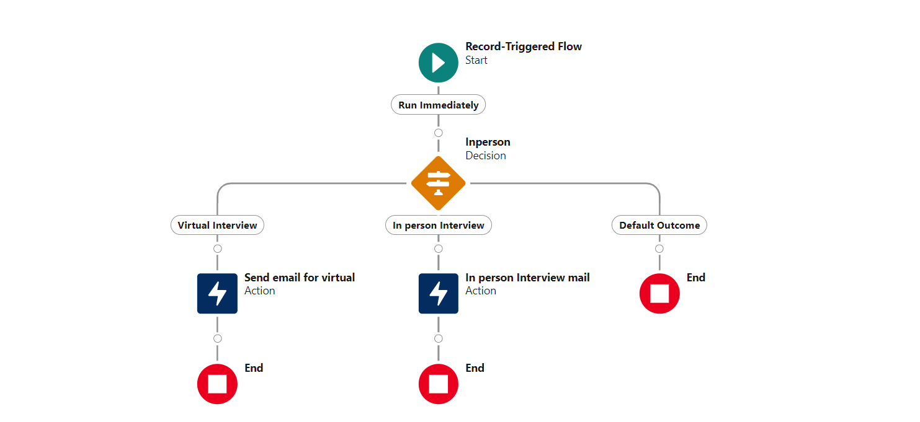

The flow follows a specific set of steps to determine the email content and recipients based on the interview status and type. It incorporates decision-making logic to ensure accurate email communication.

**Virtual Interview Scenario**

In the case of a virtual interview, the flow performs the following actions:

Sends a Teams meeting link to the applicant and all panel members.

Includes relevant details such as the interview date and time, instructions for joining the virtual meeting, and any additional information required.

**In-person Interview Scenario**

When the interview type is in-person, the flow executes the following steps:

Sends the interview location details to the applicant and all panel members.

Provides important information such as the interview date, time, and the exact location of the interview venue.

Includes any additional instructions, such as parking arrangements or directions to the location.

**Create automatically interview schedule records**

**Overview:**

This documentation provides an overview of the "Automatic Interview Scheduler" flow, which is responsible for automatically creating interview scheduler records based on certain conditions. The flow is designed to run as a record-triggered flow on the "Internal Job Applications" object. This document outlines the purpose, conditions, and flow elements of the "Automatic Interview Scheduler" flow.

**Flow Purpose:**

The purpose of the "Automatic Interview Scheduler" flow is to streamline the process of creating interview scheduler records for job applications that have passed the prescreening stage. By automating this process, the flow saves time and ensures consistent creation of interview scheduler records.

**Flow Conditions:**

The flow is triggered by a record trigger when an internal job application meets the following conditions:

The job application stage is "Prescreening."

The status of the job application is "Passed."

**Flow Elements:**

The "Automatic Interview Scheduler" flow consists of the following elements:

**Record Trigger:** The flow is initiated when a new internal job application record meets the specified conditions.

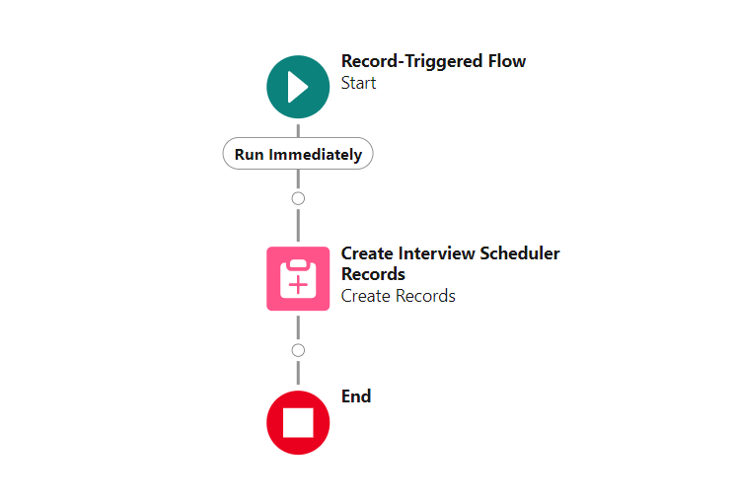

**Decision Element:** The flow includes a decision element to evaluate the job application stage and status. If the conditions are met (stage is "Pre-screening" and status is "Passed"), the flow proceeds to create interview scheduler records.

**Create Interview Scheduler Records:** This element creates the interview scheduler records based on the details of the job application. It populates relevant fields such as interview type, interview start time, end time, and location based on the requirements of the organization.

**Flow Implementation: Create Automatic Internal Interview Scheduler Records**

**Overview:**

This documentation provides an overview of the "Automatic Internal Interview Scheduler" flow, which is responsible for automatically creating internal interview scheduler records based on certain conditions. The flow is designed to run as a record-triggered flow on the "Internal Job Applications" object. This document outlines the purpose, conditions, and flow elements of the "Automatic Internal Interview Scheduler" flow.

**Flow Purpose:**

The purpose of the "Automatic Internal Interview Scheduler" flow is to automate the process of creating internal interview scheduler records for job applications that have reached the interview stage and have a status of "Scheduled." By automatically generating these records, the flow simplifies the scheduling process and ensures accuracy and consistency.

**Flow Conditions:**

The flow is triggered by a record trigger when an internal job application meets the following conditions:

The job application stage is "Interview."

The status of the job application is "Scheduled."

**Flow Elements:**

The "Automatic Internal Interview Scheduler" flow consists of the following elements:

**Record Trigger:** The flow is initiated when a new internal job application record meets the specified conditions.

**Decision Element:** The flow includes a decision element to evaluate the job application stage and status. If the conditions are met (stage is "Interview" and status is "Scheduled"), the flow proceeds to create internal interview scheduler records.

**Create Internal Interview Scheduler Records:** This element creates the internal interview scheduler records based on the details of the job application. It populates relevant fields such as interview date, interview time, interview location, and interview panel members based on the requirements of the organization.

**Email Notifications:** After creating the internal interview scheduler records, the flow triggers email notifications to the interview panel members and the applicant. The notifications contain details about the scheduled interview, including the date, time, location, and any additional instructions or requirements.

**Flow Completion:** Once the internal interview scheduler records are created and email notifications are sent, the flow completes its execution.

**Flow : Automatic Interview Feedback Creation**

**Overview:**

This documentation provides an overview of the "Automatic Interview Feedback Creation" flow, which is responsible for automatically creating interview feedback records for completed internal interview scheduler records. The flow is designed to run as a record-triggered flow on the "Internal Interview Schedulers" object. This document outlines the purpose, conditions, and flow elements of the "Automatic Interview Feedback Creation" flow.

**Flow Purpose:**

The purpose of the "Automatic Interview Feedback Creation" flow is to automate the process of generating interview feedback records for internal interview scheduler records that have been marked as completed. By automatically creating these records, the flow streamlines the feedback collection process and ensures timely and accurate feedback from interviewers.

**Flow Conditions:**

The flow is triggered by a record trigger when an internal interview scheduler record meets the following condition:

The status of the internal interview scheduler record is "Completed."

**Flow Elements:**

The "Automatic Interview Feedback Creation" flow consists of the following elements:

**Record Trigger:** The flow is initiated when a new internal interview scheduler record is marked as completed.

**Decision Element**: The flow includes a decision element to evaluate the status of the internal interview scheduler record. If the status is "Completed," the flow proceeds to create interview feedback records.

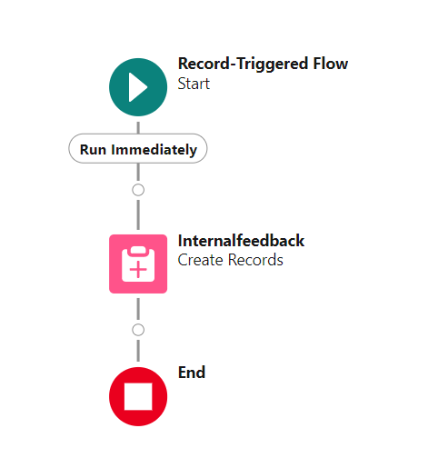

**Create Interview Feedback Records**: This element creates interview feedback records based on the details of the completed internal interview scheduler record. It captures feedback from interviewers, including their assessments, comments, and recommendations.

**Save and Associate Feedback**: The flow saves the interview feedback records and associates them with the corresponding internal interview scheduler record. This ensures that the feedback is linked to the specific interview session.

**Flow Completion:** Once the interview feedback records are created and associated, the flow completes its execution.

**Record Trigger Flow for Custom Notifications on Internal Job Application Updates (user story 5.4.3)**

**Introduction**

The purpose of this documentation is to provide an overview of the record trigger flow that sends custom notifications to employees, HR managers, and reporting managers when an internal job application record is updated to the "Interview" status and "Qualified" stage. This flow automates the process of sending notifications to the relevant parties and ensures timely communication during the hiring process.

**Flow Overview**

The record trigger flow is designed to trigger whenever an internal job application record is updated. It checks the status and stage of the application and sends custom notifications to the appropriate recipients. The flow follows these steps:

**a. Trigger:** The flow is triggered whenever an internal job application record is updated.

**b. Condition Check:** The flow checks if the status of the internal job application is set to "Interview" and the stage is "Qualified". If the condition is met, the flow proceeds to the next step.

**c. Get User Records:** The flow retrieves the user records associated with the relevant employees, HR managers, and reporting managers. It retrieves the User IDs based on predefined criteria, such as the employee's role or relationship to the job application.

**d. Loop through User IDs:** The flow loops through the retrieved User IDs to process each user record individually.

**e. Assign Recipient IDs**: Within the loop, the flow assigns the recipient IDs for the custom notification action. This step ensures that the notification is sent to the correct individuals based on their roles and relationships.

**f. Send Custom Notification:** The flow uses an action to send the custom notification to the assigned recipient IDs. The notification body may include relevant details about the interview, such as the interview date, time, location, and any additional instructions.

**Benefits**

The record trigger flow for custom notifications on internal job application updates offers several benefits, including:

**Automation:** The flow automates the process of sending notifications, saving time and effort for HR personnel and ensuring timely communication.

**Personalized Notifications:** The custom notifications can be tailored to include specific information relevant to each recipient, enhancing the user experience and providing clarity about the interview process.

**Efficient Communication**: By notifying employees, HR managers, and reporting managers promptly, the flow enables effective coordination and ensures that all parties are informed about interview updates.